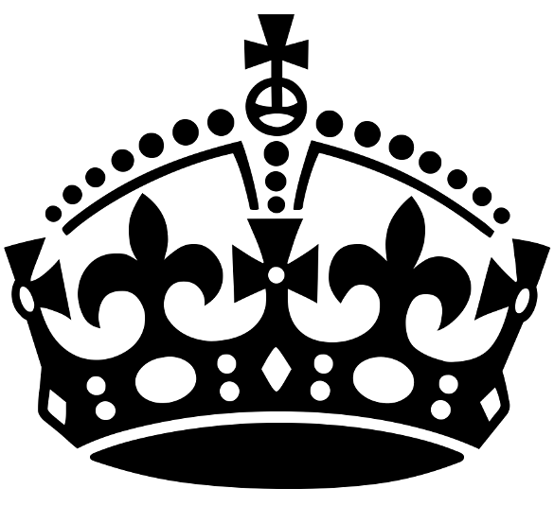
KEEP
CALM

AND REVISE HISTORY!
W/C | Focus | Prep work | Revision session | Consolidation
11 March | Paper 1  USA | Watch Pods on the following:  American people and the ‘boom’- Changing roles for women  Post-war America- Development of the Feminist Movement and The Impact of Feminism | Content: Women’s roles in USA  Technique: Explanation (Q3) | Create a timeline of the changes to women’s roles in society from 1920-1973
18 March | Paper 1  Conflict | Watch Pods on the following:  Origins and Outbreak of the Second World War- Aims of Hitler’s Foreign Policy, Hitler and the Austrian Anschluss, An Evaluation of the Policy of Appeasement | Content: Anschluss  Technique: Utility | Create a story board of Hitler’s road to WW2 showing his actions in foreign policy and where he broke the ToV
25 March | Paper 2  Health | Watch Pods on the following:  From ALL sections- Hippocrates, Galen and the Four Humours, Paré, Edward Jenner, Fleming, Florey and Chain and Penicillin, McIndoe and Plastic Surgery | Content: Individuals  Technique: Similarities (Q3) | Create mini-biography of each showing their work and impact on the development of medicine
1 April | Paper 1  USA | Watch Pods on the following:  Post-war America- Impact of WW2 on Black Civil Rights, Position of Black Americans in the 1950s, Role of Martin Luther King, Black Power, Civil Rights Legislation (1 and 2) | Content: Civil Rights Movement  Technique: Judgement (Q6) | Make a mind-map of the Civil Rights Movement colour-coded to show the different groups and individuals
8 April | Paper 2  Elizabeth | Watch Pods on the following:  Life in Elizabethan Times- Living Standards and Poverty | Content: Poverty  Technique: Importance (Q2) | Write a glossary of key terms
22 April | Paper 2  Health | Watch Pods on the following:  From ALL sections- Treatments: The Natural, the Supernatural and Astrology, Approaches to treatment, Magic Bullets, Treatment in Industrial Britain, Alternative Medicine | Content: Treatments  Technique: Utility | Explain how treatments have developed over time. Give examples from every era and use a PEEL structure
29 April | Paper 1  Conflict | Watch Pods on the following:  League of Nations and International Peace- Attempts at Peacekeeping 1920s, League’s social and economic work, Locarno Treaties and Kellogg-Briand Pact | Content: Other Treaties  Technique: Judgement Essay | Make a living graph showing the successes and failures of the League of Nations in the 1920s and 1930s
6 May | Paper 1  USA | Watch Pods on the following:  Bust- Experiences of the Depression- The Great Depression, Hoover’s response, 1932 Election, The New Deal, Opposition to the New Deal | Content: The New Deal  Technique: Interpretations (Q3) | Draw a table showing the New Deal actions on one side and opponents and their reasons for opposition on the other
13 May | Paper 1  Conflict | Watch Pods on the following:  Peacemaking- Background to the Paris Peace Settlements, The Versailles Treaty, The Impact of the ToV on Germany, Assessment of the Treaty of Versailles | Content: Impact of ToV  Technique: Account | Annotate the sources to say what they show about the ToV and add some extra knowledge
20 May | Paper 2  Health | Watch Pods on the following:  From ALL sections- Medieval medics, Changing nature of Hospitals and Medical Professions, Pare, Industrialisation and its Impact, Simpson, Lister, Modern Surgery, McIndoe and Plastic Surgery, Barnard and Transplants | Content: Anatomy and Surgery  Technique: Thematic Essay | Create a timeline showing the changes to surgery from medieval to modern, and highlight the key individuals
27 May | Paper 2  Elizabeth | Watch Pods on the following:  Trouble at home and abroad- Relations with Spain, outbreak of war with Spain  Life in Elizabethan times- Exploration and voyages of discovery | Content: Drake’s circumnavigation  Technique: Historic Environment | Write quiz questions about the site to self-test

