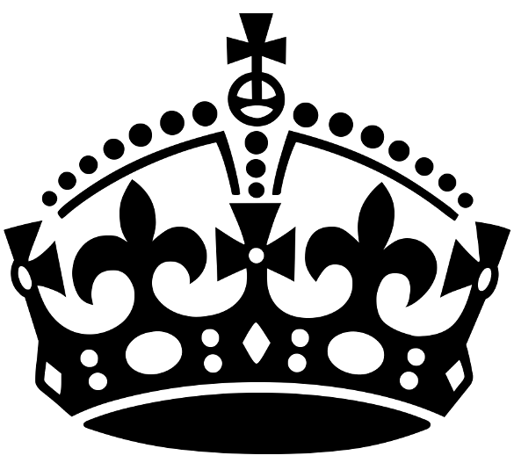
KEEP CALM
AND HELP STUDENTS WITH THEIR REVISION!
How to Help History Newsletter April 2024
Two years of KS4 have almost finished and the end of Year 11 is in sight! In History we are concentrating on revising content for both Paper 1 and Paper 2 as well as practising technique. Revision has been planned by each class teacher and is based upon mock exam results. Included in this issue of How to Help is details about how you can best support your child to focus and achieve well in History.

Exams
Students are aware of the units they will be sitting, and they have recently completed a mock in all four units.
The mock results should be used to highlight and identify areas where students need to improve- this is likely to be focused on one of the following:
- Securing knowledge of the content
- Practising exam technique with sample questions

Both of these areas will be covered in revision in class as well as in after school revision sessions, but it would be worthwhile to speak to your child to ensure they know where to focus their attention in their independent revision.

The mock exams are a really important and useful tool to give an idea of how well students might perform in their exams, however if the result is not as your child might have hoped there is still time to focus on those areas for improvement. With some hard work from the students and help from the History Department, a good grade is well within reach!

Exam
History GCSE is comprised of two papers, one exam for each. The date for these exams is given below:
Paper 1- USA and Conflict & Tension Wednesday 15th May 2023 am
2 hours, one hour for each unit
Paper 2- Health and the People and Elizabethan England Tuesday 4th June 2023 pm
2 hours, one hour for each unit

How can I help my child achieve well in History?
Revision Sessions
Revision in History has been running alternate Mondays since January. Students who have been identified from their mock results as requiring additional support will be invited to sessions. If invited, it is essential that your child attend, so that we can help to assist in their revision. If there is a conflict with another subject or activity please get in touch with your child’s class teacher to make alternative arrangements. If your child is not invited to the sessions they are still very welcome to attend- we hope to see as many Year 11 Historians there as possible as they will all benefit from the additional support.
Revision Hub
On the Year 11 Revision Hub there is a revision plan. This is not compulsory but it is a really useful planning tool for students to organise their independent study.
Preparation activities will consist of GCSE Pods to watch and make notes on. All of Year 11 have access to GCSE Pod, which is an invaluable to help students to recap and revise the key content of each topic. All students have an account set up and have their log in details written down.
Websites
The following websites are recommended for students to access:
GCSE History - AQA - BBC Bitesize- Useful for content on Elizabeth and Health
historylearningsite.co.uk/
johndclare.net/
spartacus-educational.com/
schoolhistory.co.uk/
historyresourcecupboard.co.uk/content/
bbc.co.uk/teach/class-clips-video/medicine-through-time
https://www.monkeymonkeyrevision.co.uk/ - Useful for content on Elizabeth and Health

The department has a number of revision guides which can be requested if internet access is proving to be problematic.

Revision activities to try

Finally, independent revision activities which prove particularly useful for History are:
- Timelines of key events and dates
- Profiles of key individuals
- Flashcards with notes and self-quiz questions
- Mind maps to show links and connections between topics
- Practise exam questions

Course booklets
All pupils have been given

If you have any questions or would like more information, please do not hesitate to contact me at school or alternatively drop me a message via Class Charts.

Mrs N Richardson
Head of History

