SCHOOL EQUIPMENT

All pupils must have a suitable pencil case (can be any type or colour), containing the following equipment. Pupils must bring this equipment with them each day they are in school and keep it in good condition.

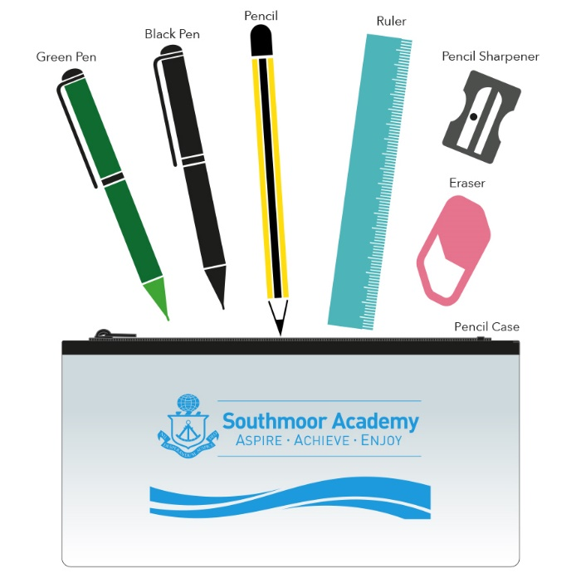

It is recommended that pupils bring a suitable bag to school each day.

Please turn over…

The required equipment for every day at Southmoor is:
- A Black Pen
- A Green Pen
- A Pencil
- A Ruler (15cm)
- A Pencil Sharpener
- An Eraser
- A Pencil Case to hold all of the above
- A re-usable water bottle. Sports-type or metal. Water dispensers are positioned around the Academy, where pupils can replenish their bottles at lunch time. Please note that other drinks such as energy, soft and carbonated drinks are prohibited and must not be brought in to school. Pupils will have the option to purchase a healthy juice drink, alongside free access to water.
Please note: All of the above equipment can be replenished at the in-school shop, open every day at break time.

Pupils may also consider bringing:
- Colouring pencils
- Highlighters
- A calculator
- An inexpensive wrist watch
.
Pupils should not bring:
- Headphones
- Mobile Phones (Although we accept that a mobile phone is sometimes necessary for parent-pupil contact before and after school, for safeguarding purposes, phones should be turned off during the school day and remain out of site. Phones should never be used at any point during the school day or on school premises. Phones will be confiscated by staff should students be seen using them or other connected devices. Please also note that the Academy will take no responsibility for any such items brought into school that may become damaged, lost or stolen)
- ‘Tippex’ or eraser fluid
- Scissors or any other sharp object
- Marker pens (except highlighters)

